Procedure: Selection and Use of Specialized Chemical Protective Ensembles

Purpose:

Thus policy is intended to comply with the Emergency Response Plan requirements of OSHA 29 CFR 1910.120(q)(2) regarding the selection and use of specialized personal protective equipment (PPE) by properly trained hazardous materials team members in the emergency response setting.

Applicability:

This policy shall be utilized to guide the selection and use of various protective ensembles based upon the identified or anticipated hazards to be encountered during a hazardous materials emergency. It is the incident commander’s responsibility to ensure that the procedures outlined in this policy are implemented using the technical input of a knowledgeable Safety Officer and HazMat Group Supervisor.

Specialized Chemical Protective Ensembles:

Chemical protective ensembles shall be selected based upon the hazards that are anticipated in the work area. When selecting the ensemble the following information shall be evaluated:

- Identity of the material involved (if known) and its associated hazards
- Physical state of the material (solid, liquid, gas)
- Potential routes of chemical exposure (inhalation, contact, absorption, etc..)
- Anticipated job function, proximity to and contact with the materials (incidental contact, repeated contact, immersion)
- If the airborne concentration of the material known or anticipated to exist above published exposure limits or the Immediately Dangerous to Life and Health (IDLH) concentration
- Anticipated oxygen concentrations
- Other physical hazards that may exist (sharp metals, confined spaces, fire hazards, dangerous noise levels, etc.)
- Chemical compatibility of the garment based first upon manufacturer test data including ASTM chemical test battery.

Based upon the assessment of this information, the following table represents general considerations for ensemble selection.

NFPA 1991 VAPOR PROTECTIVE (LEVEL A)
Compliant for Thermal and Abrasion Resistance
 | Generally Used When | Not to be used when | Chemical Protective Ensemble | Optional Equipment
NFPA 1991 VAPOR PROTECTIVE (LEVEL A)  Compliant for Thermal and Abrassion Resistance | - Atmospheres with known or potential IDLH concentrations with skin route of exposure, or  - When contact, repeated splash or immersion in product that is dangerous to the skin is anticipated (other than incidental contact), or  - For entries into enclosed or poorly ventilated areas during releases of gases or high vapor pressure liquids (> 100mm/Hg) that are dangerous to the skin, or  - Unidentified, poorly ventilated atmospheres in which situations indicate a possibility of an IDLH environment and other engineering controls can not be used to reduce concentrations,  and  - Material has flammable properties and the presence of a flammable atmosphere cannot be controlled, or  - Scene hazards and work mission indicates high potential for abrasion and/or puncture and tears to the garment | Engineering controls can be implemented that will reduce flammability and abrasion /tear hazards to acceptable levels  Note: Due to the extreme limitations of movement, communications, vision and dexterity that are created by this level of protection, every effort should be made to reduce scene hazards through engineering controls and monitoring prior to implementation. | - PP/SCBA  - NFPA 1991 Level A garment with appropriate flash protective layer  - Surgical gloves  - Inner chemical resistant gloves  - Outer chemical resistant gloves  - Outer puncture/tear resistant gloves.  - In-suit radio system  - Chemical resistant outer boots | Depending upon mission and scene hazards:  - Helmet if falling debris or head strikes are possible  - Hearing protection if situation dictates  - Long sleeve coveralls if environmental conditions dictate

VAPOR PROTECTIVE (LEVEL A)
Non-NFPA 1991
 | Generally Used When | Not to be used when | Chemical Protective Ensemble | Optional Equipment
VAPOR PROTECTIVE (LEVEL A)  Non-NFPA 1991 | - Atmospheres with known or potential IDLH concentrations with skin route of exposure, or  - When contact, repeated splash or immersion in product that is dangerous to the skin is anticipated (other than incidental contact), or  - For entries into enclosed or poorly ventilated areas during releases of gases or high vapor pressure liquids (> 100mm/Hg) that are dangerous to the skin, or  - Unidentified, poorly ventilated atmospheres in which situations indicate a possibility of an IDLH environment and other engineering controls can not be used to reduce concentrations | Flammable Environments  - Use engineering controls to reduce flammability hazards, then  - Upgrade to NFPA 1991 compliant garment  High physical Cut and tear hazards  - Upgrade to NFPA 1991 compliant garment  Low Temperatures  - Low temperatures requiring additional thermal protection. Then Upgrade to NFPA 1991 Compliant Garment. | - PP/SCBA  - Vapor Protective Garment  - Surgical gloves  - Inner chemical resistant gloves  - Outer chemical resistant gloves  - In-suit radio system  - Chemical resistant outer boots | Depending upon mission and scene hazards:  - Helmet if falling debris or head strikes are possible  - Outer work gloves to protect chemical gloves if work mission dictates  - Hearing protection if situation dictates  - Long sleeve coveralls if environmental conditions dictate

Level “B” Protective Ensemble (Non-Encapsulating)
(Solid or liquid contact, High respiratory protection)
 | Generally Used When | Not to be used when | Chemical Protective Ensemble | Optional Equipment
Level “B” Protective Ensemble (non-encapsulating)  (Solid or liquid contact, High respiratory protection) | - IDLH-Inhalation environment known or possible, and  - No IDLH Skin atmosphere present or likely (e.g. low vapor pressure liquids or high concentrations of water soluble/skin absorbable vapors/gases or, hydroscopic corrosive gases/vapors)  - Possible oxygen deficient atmosphere  - Direct contact with product that can injure the skin is limited only to an incidental splash. Repeated contact is unlikely  - Minimum level of protection for un-identified environment and will be used in conjunction with appropriate air monitoring procedures | - Potential IDLH-Skin conditions exist  - When in enclosed or confined areas with spills of high vapor pressure liquids or gases that may be injurious to/or absorbed through the skin are possible  - When repeated contact or immersion in the product is likely.  Flammable Environments  - Use engineering controls to reduce flammability hazards. Otherwise, additional thermal protective garments will be required. | - PP/SCBA  - Liquid splash protective coverall garment  or,  - Particulate contact protective coverall garment  - Surgical gloves  - Chemical resistant outer gloves  - In-suit radio system  - Chemical resistant outer boots | Depending upon mission and scene hazards:  - Helmet if falling debris or head strikes are possible  - Hearing protection if situation dictates  - Outer work gloves to protect chemical gloves if work mission dictates  - Long sleeve fire resistant coveralls

Level “B” Protective Ensemble (Encapsulating)
(Solid or liquid contact, High respiratory protection)
 | Generally Used When | Not to be used when | Chemical Protective Ensemble | Optional Equipment
Level “B” Protective Ensemble (encapsulating)  (Solid or liquid contact, High respiratory protection) | - IDLH-Inhalation environment known or possible, and  - No IDLH Skin atmosphere present or likely (e.g. low vapor pressure liquids or high concentrations of water soluble/skin absorbable vapors/gases or, hydroscopic corrosive gases/vapors)  - Possible oxygen deficient atmosphere  - Direct contact with product that can injure the skin is limited only to an incidental splash. Repeated contact is unlikely  - Minimum level of protection for un-identified environment and will be used in conjunction with appropriate air monitoring procedures  and/or  - There is a need to reduce splash contact hazards and to protect SCBA or other protective equipment  - There is a desire to minimize extensive decon operations.  - There is a desire to reduce heat stress of personnel stand-by modes of operation (e.g. decon personnel). | - Potential IDLH-Skin conditions exist  - When in enclosed or confined areas with spills of high vapor pressure liquids or gases that may be injurious to/or absorbed through the skin are possible  - When repeated contact or immersion in the product is likely.  Flammable Environments  - Use engineering controls to reduce flammability hazards. Otherwise, additional thermal protective garments will be required. | - PP/SCBA  - Encapsulating liquid splash protective garment  - Surgical gloves  - Chemical resistant outer gloves  - In-suit radio system  - Chemical resistant outer boots | Depending upon mission and scene hazards:  - Helmet if falling debris or head strikes are possible  - Hearing protection if situation dictates  - Outer work gloves to protect chemical gloves if work mission dictates  - Long sleeve fire resistant coveralls

Level “C” Protective Ensemble
(Solid or liquid contact, Known Respiratory Hazards)
 | Generally Used When | Not to be used when | Chemical Protective Ensemble | Optional Equipment
Level “C” Protective Ensemble  (Solid or liquid contact, Known Respiratory Hazards) | - No IDLH environment known or possible, and  - Oxygen between 19.5 and 23.5%  - Identity of the material is known, and  - Airborne concentrations are known to be below IDLH concentrations and within the protection factor of the respirator to be used, and  - The appropriate respirator cartridge is available for the material, and  - Warning properties are sufficient to indicate that breakthrough has occurred  - No Flammability hazards are present | - Any potential for IDLH either skin or inhalation is present  - When in enclosed or confined areas with spills of high vapor pressure liquids (>100 mm/Hg) or gases and air monitoring has not been performed to measure the potential exposure levels  - When repeated contact or immersion in the product is likely  Flammable Environments  - Use engineering controls to reduce flammability hazards | - Full Face Negative Pressure Air Purifying Respirator (APR) with a NIOSH assigned protection factor of 10:1 or Powered Air Purifying Respirator (PAPR) with a NIOSH assigned protection factor of not less than 50:1, and  - Used with either P100 particulate cartridge or, Organic Vapor/Acid Gas/P100, or contaminate specific filter which ever can be used for the environment to be encountered  and,  - Liquid splash protective coverall garment of  or,  - Particulate contact protective coverall garment of Dupont Tyvek® or Laminated Tyvek®  and,  - Surgical gloves  - Chemical resistant outer gloves of either Butyl, Viton®, Nitrile or PVC.  - Chemical resistant outer boots (red neoprene or green HazMax®) | Depending upon mission and scene hazards:  - Helmet if falling debris or head strikes are possible  - Hearing protection if situation dictates  - Outer work gloves to protect chemical gloves if work mission dictates  - Long sleeve fire resistive coveralls  - In suit radio communications are optional due to lack of IDLH environment

Equipment and Supply Stocking Levels:

In order to support this policy, the following materials shall be maintained at the identified levels

Item | Specification | Quan | Location
Vapor Protective  (Level A) Garment,  Non-NFPA 1991 | Brand  Model #  Options
Vapor Protective  (Level A) Garment,  NFPA 1991 Compliant  Thermal/Abrasion resistant ensembles | Brand  Model #  Options
Liquid/Particulate Splash Protective  (Level B/C) Garment | Brand  Model #  Options
P100 Particulate filters | Brand  Model #
OV/Acid Gas/P100 filters | Brand  Model #
P100 Filters | Brand  Model #
OV/Acid Gas/P100 filters | Brand  Model #
Dressout Kits | Example  Each Dressout kit shall contain  1 ea – CPF 3 garment  2 pr – Butyl rubber gloves (black)  2 pr – Nitrile rubber gloves (green)  2 pr – PVC gloves (heavy green)  1 bag – surgical gloves  4 pr – Silver shield gloves  1 pr – Neoprene or Hazmax boots (sz 13)  1 roll – ChemTape®  1 ea – Water bottle  1 pr – P100 Filters

Level A Garment Testing & Documentation:

All vapor protective garments shall be scheduled for regular rotational replacement in accordance with manufacturer recommendations. All vapor protective garments shall be tested in accordance with the manufacturer recommendations at time of delivery, after any donning and periodically based upon the following schedule.

Garments | Quantity/Location | Frequency | Schedule
Vapor Protective (Level A)
non-1991
Vapor Protective (Level A)
NFPA 1991 Complaint

All use, test or repairs shall be recorded in accordance with manufacturer recommendations and a copy of the documentation shall be maintained with the garment.

Any deficiencies shall be documented and repaired in accordance with manufacturer recommendations and agency policies.

Garment Decontamination and Reuse:

Limited use vapor protective garments shall not be returned to service after chemical contamination occurs with the following exception. Garments may be reused during the same incident provided: 1) published breakthrough times are observed, and 2) decontamination has occurred and no visible signs of garment degradation or damage are present.

When a garment is removed from service, it shall be disposed of or destroyed in such a manner that it cannot be reused.

Optional Job Aids:

Four job aids are attached for the purpose of assisting with the selection and use of the appropriate level of protection. These job aids are:

- Protective Ensemble Selection Worksheet
- Respiratory Portection Decision Diagram
- Level A and Level B donning checklists

PROTECTIVE ENSEMBLE SELECTION WORKSHEET

STEP 1: MATERIAL HAZARD ASSESSMENT
MATERIAL INVOLVED |  |  |  |  |  |  | CAS No.
PHYSICAL STATE
VAPOR PRESSURE: |  |  |  | mm/Hg at degrees F
MAXIMUM CONCENTRATION CALCULATION |  |  |  | (__________ / 760 mm/Hg) x 1,000,000 = _______  Vapor Pressure (Max. Conc.)
ROUTES OF EXPOSURE
LOWEST ESTABLISHED  TIME WEIGHTED AVERAGE |  | ____________ / ___ HR  SOURCE:  [ ] OSHA/PEL [ ] NIOSH/REL  [ ] ACGIH/TLV [ ] OTHER |  |  |  | NIOSH / IDLH |  |  |  | ___________
STEP 2: ASSESS ANTICPATED CONCENTRATIONS
STEP | EVALUATION |  |  |  | LOGIC |  |  |  |  | RESULTS
2-A | Has monitoring been performed? |  |  |  | Yes [ ]  No [ ] Level B Minimum and skip to 3
2-B | Assess IDLH Atmospheres  - Is atmosphere above IDLH?  - If over IDLH, does the product have skin absorption or direct contact hazards? [ ] yes [ ] no |  |  |  | If no, then skip to 2-C  If yes, then Level A ->  If no, then PP/SCBA ->
2-C | Assess Appropriate Respiratory Protection:  - Is concentration below IDLH but above TWA? [ ] yes [ ] no  - Is concentration below TWA without possibility of increase? [ ] yes [ ] no |  |  |  | If yes, go to 2-D  If yes, then Respiratory protective equipment is not required. Skip to step 3.  If no, then assess possibility of APR use.
2-D | Assess Possibility of PAPR use  Use this section only if product is below IDLH concentrations without possibility of increase.  - Is oxygen concentration above 19.5 %? [ ] yes [ ] no  - Is the proper PAPR filter available for the material involved?  [ ] yes [ ] no  - Multiply the TWA by 50 to determine the maximum usable concentration for a full-face piece PAPR unit.  TWA x 50 =________  - Is the value entered above greater than the known airborne concentration?  [ ] yes [ ] no |  |  |  | If no, then PP/SCBA is required ->  If no, then PP/SCBA is required ->  If yes, then PAPR can be used ->  If no, the PP/SCBA should be used ->
STEP 3: DETERMINE GARMENT TYPE
3-A | Assess need for Level A  - Is a route of exposure either skin absorption or skin contact.  [ ] yes [ ] no  - Is the concentration above the IDLH/skin? [ ] yes [ ] no  - Is repeated contact or immersion in the product anticipated or possible? [ ] yes [ ] no  - If you answered "no" to the two questions immediately above then level A may not be necessary. Consider whether total coverage level B may be required to protect respiratory protective equipment. |  |  |  | If no, level A is not required. Select level B and skip to 4  If yes, then Level A and skip to step 4.  If yes, then Level A and skip to step 4.

STEP 4: ASSESS GARMENT COMPATABILITY
4-A |  | Review garment compatibility data to determine highest rating or applicability of current garments. Insure breakthrough times leave a minimum of a 5:1 safety margin when compared to estimated work mission duration
Material Type |  | Man. Provided Breakthrough Data | CAMEO RIDS  Breakthrough Data | Other Breakthrough Data | Select Best
Garment Type:
Butyl Gloves
Nitrile Gloves
Viton Gloves
PVC Gloves
Norfoil® (Silver Shield®)
Neoprene Boots
HazMax Boots
4-B | Assess Specific Garment Compatibility  - What is the breakthrough time for the Dupont Tychem Responder Garment? __________ Minutes  - What is the breakthrough time for the Dupont Tychem CFP3 Garment? ____________ Minutes

STEP 5: DETERMINE ACCESSORIES
5-A | Thermal Hazards  - Does monitoring show % of LEL greater than accepted action levels?  [ ] yes [ ] no  - Are engineering controls successful? [ ] yes [ ] no  - Are liquefied gases or cryogenics leaking. [ ] yes [ ] no  - Is the weather cold? [ ] yes [ ] no  - Is it above 85 degrees or will work be carried out in direct sunlight? [ ] yes [ ] no | If yes, attempt engineering controls to reduce below action levels. ->  If no, consider risk benefit and utilize fire resistive protective undergarments and flash covers. ->  If yes, consider cold protection. Contact with cryogenic materials will destroy garments. ->  If yes, insure proper undergarments. ->  If yes, take extra heat stress precautions. ->
5-B | Etiological Hazards  - Are there any etiological hazards for which mortality rate is high or treatments unknown.  [ ] yes [ ] no  - Will garments be reused during the operation. [ ] yes [ ] no | If yes, insure proper protection for route of exposure. Insure disinfecting decontamination.  If yes, insure proper disinfection prior to reuse.
5-C | Asphyxiation Hazards  - Are there any asphyxiation hazards which have not previously been addressed? [ ] yes [ ] no | If yes, adjust level of protection appropriately
5-D | Mechanical Hazards  Consider all of the following and take appropriate engineering controls or protective measures.  - Excessive noise (engineering controls then hearing protection)  - Possibility of suit punctures or tears (engineering controls then tear/puncture resistant garment)  - Glove tears (Outer work gloves)  - Falling objects (secure and head protection)  - Trip and Fall hazards (engineering controls, guarding, safety lines, etc)  - Explosion hazards (blast resistant shielding, remote opening, distance)  - Violent chemical reactions (consider heat generation, container failures, segregate materials)
5-E | Chemical Hazards  If there are any other chemical hazards not previously addressed, adjust personal protective equipment accordingly.
5-F | Psychological Hazards  Consider psychological impacts and insure thorough briefing, debriefing and potential CISD needs.
5-G | Radiological Hazards  - Insure monitoring is performed at all times  - Absolute maximum exposure is 25 REM  - Time: Control entry times  - Distance: Maintain distance  - Shielding: Consider shielding measures  - Assistance: Gain assistance of health physicist

Vapor Protective Ensemble or
Encapsulating Splash Protective Ensemble

Donning Checklist

- Visually inspect protective garment for damage and discoloration
- Personnel shall remove non-essential articles e.g.; jewelry, wallets, sharp Objects , and contact lenses ect.

- Apply anti-fog to any lenses (suit, mask, and spectacle kit if used
- Don undergarment if applicable
- Don encapsulating suit up to waist height
- Don safety boots and if applicable, disposable boot covers.
- Don first pair of inner gloves

Don SCBA backpack
- Don communications equipment
- Don SCBA facepiece
- Don helmet if applicable and secure
- Perform radio check with entry coordinator

WAIT FOR PERMISSION TO GO ON AIR

- Go on air, log time and air pressure.
- Finish donning the suit, and zip garment closed
- Don outer gloves
- Perform Buddy Check

Coverall Style Splash Protective Ensemble
(Level B or C)

Donning Order Check List

- Visually inspect protective garment for damage and discoloration
- Personnel shall remove non-essential articles e.g.; jewelry, wallets, sharp objects, and contact lenses ect.

- Apply anti-fog to any lenses (suit, mask, and spectacle kit if used)
- Don undergarment if applicable
- Don Level B garment
- Don safety boots and if applicable, disposable boot covers and seal if applicable.
- Don inner gloves and outer gloves, seal as applicable
- Don SCBA backpack or PAPR power unit
- Don communications equipment
- Don SCBA facepiece and seal if applicable
- Don helmet if applicable and secure
- Perform radio check with entry coordinator

WAIT FOR “GO ON AIR” ORDER

- Go on air, log time and air pressure
- Don outer gloves if applicable
- Perform Buddy Check
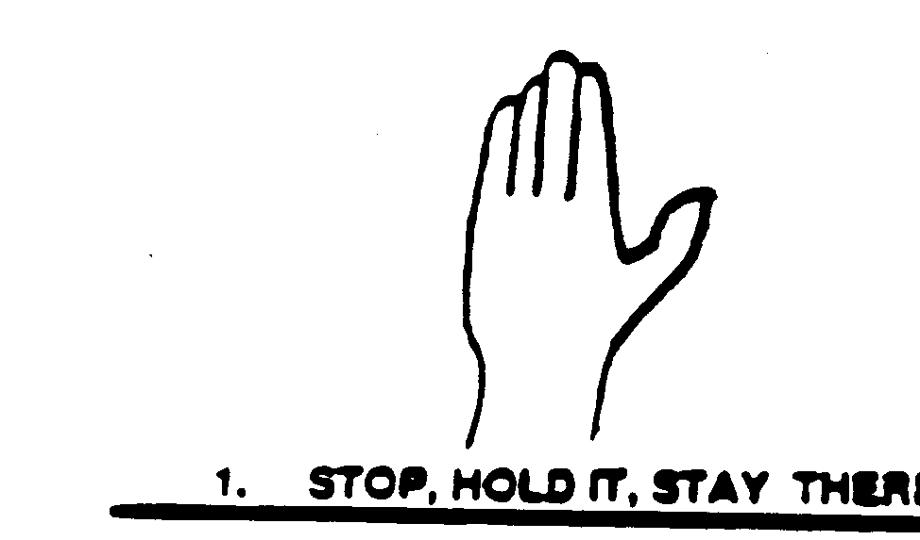
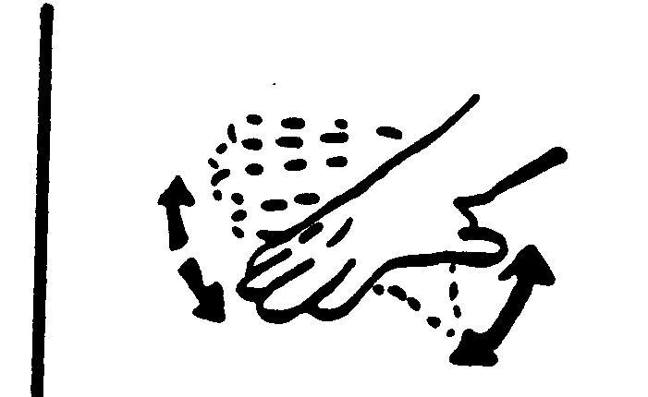
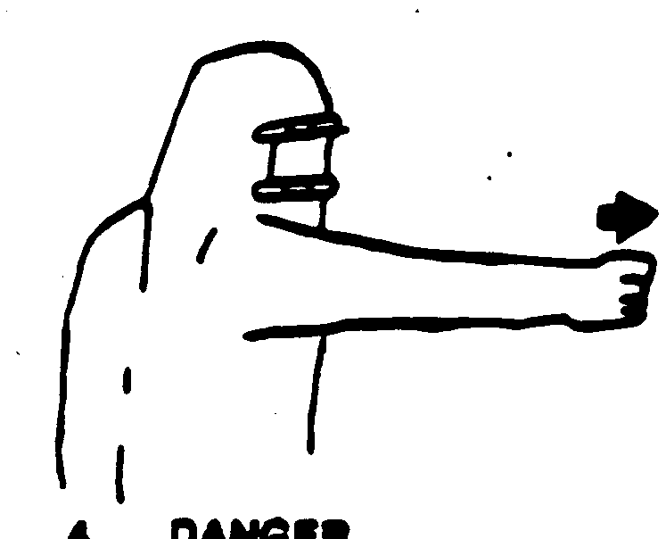
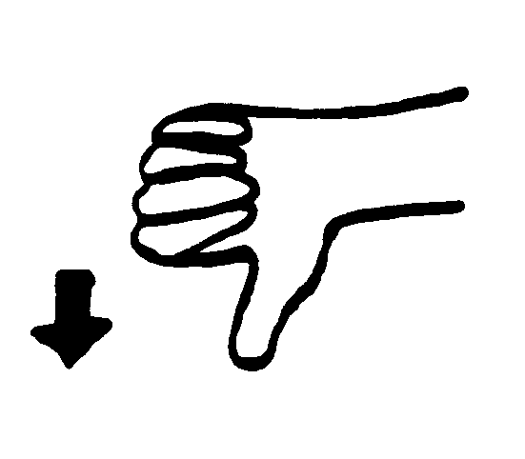
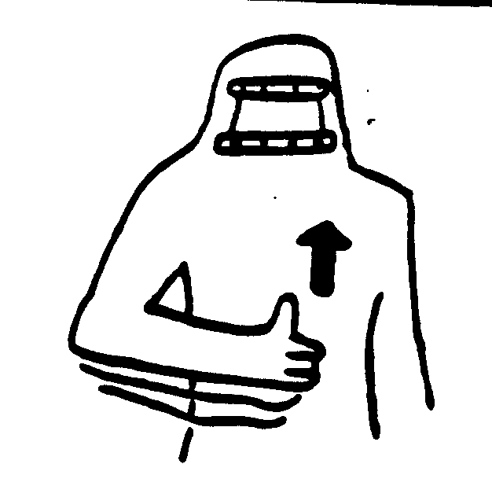
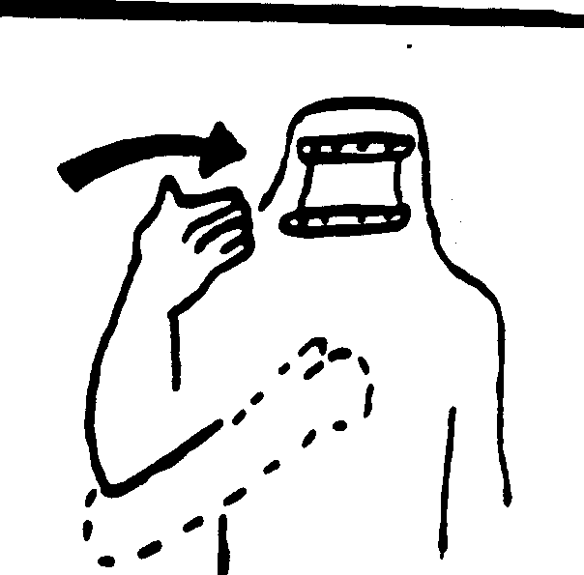
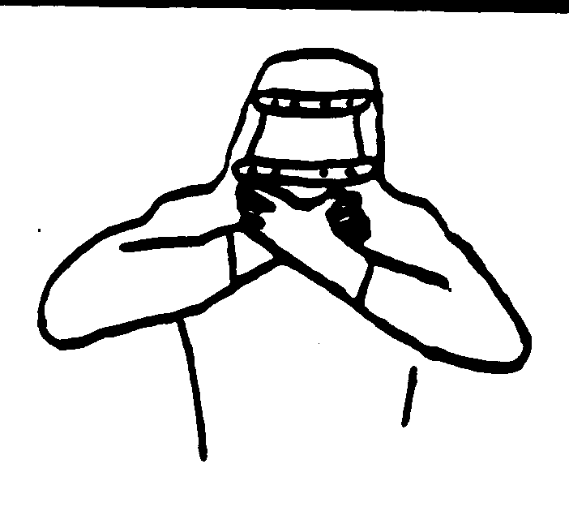
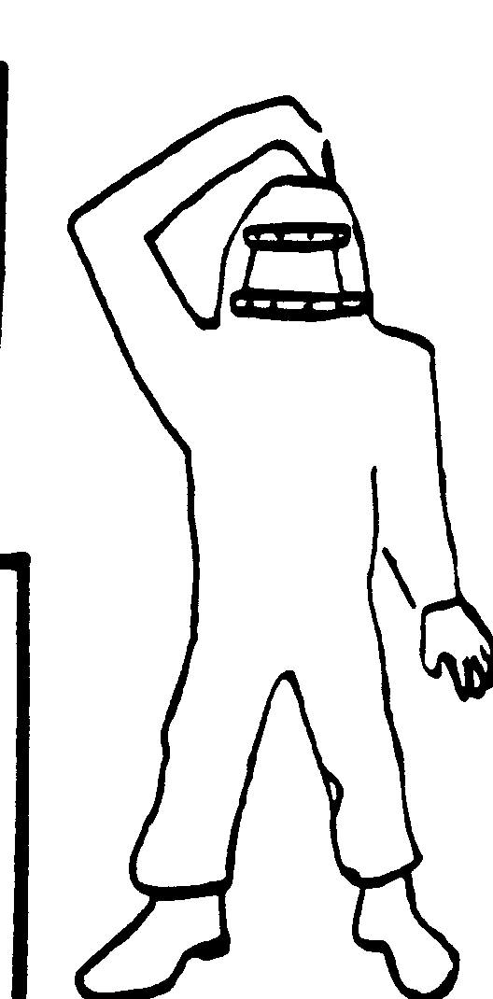
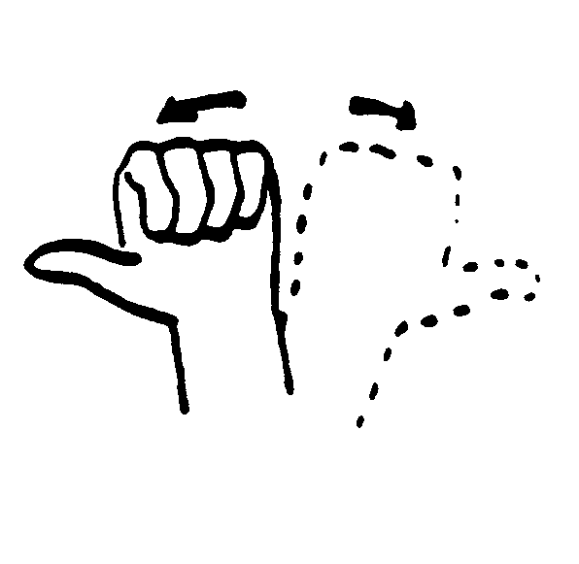
Standardized Hand Signals
STOP, HOLD IT, STAY THERE
SOMETHING IS WRONG
DANGER
GO DOWN, GETTING DOWN
GO UP
COME HERE
OUT OF AIR
OK
WHICH WAY?


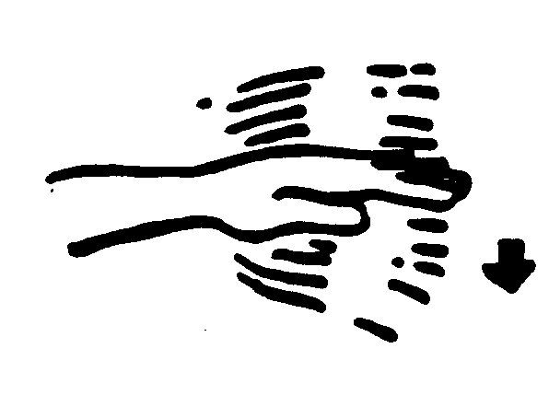
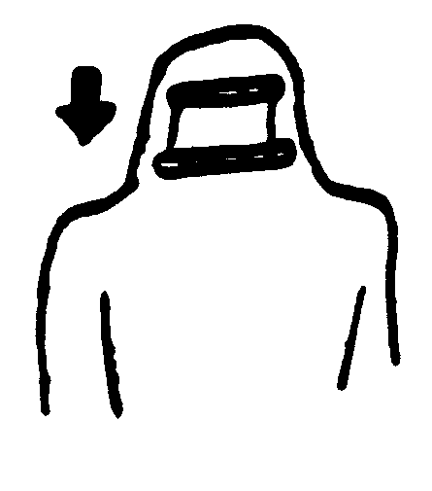
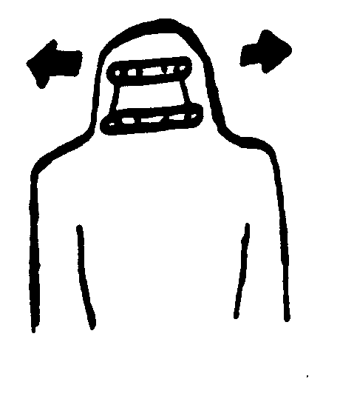
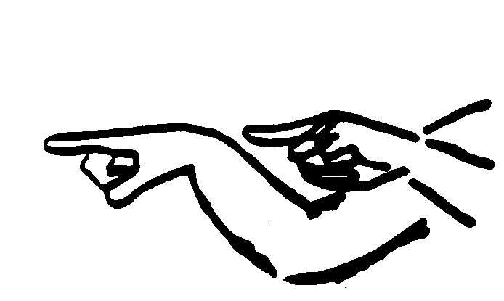
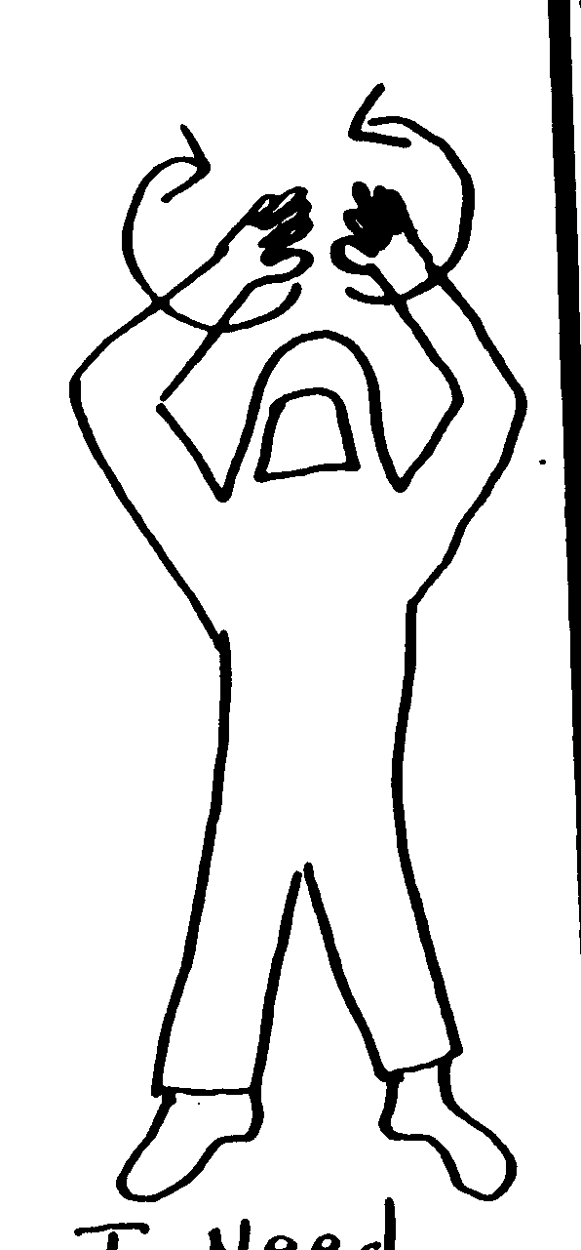
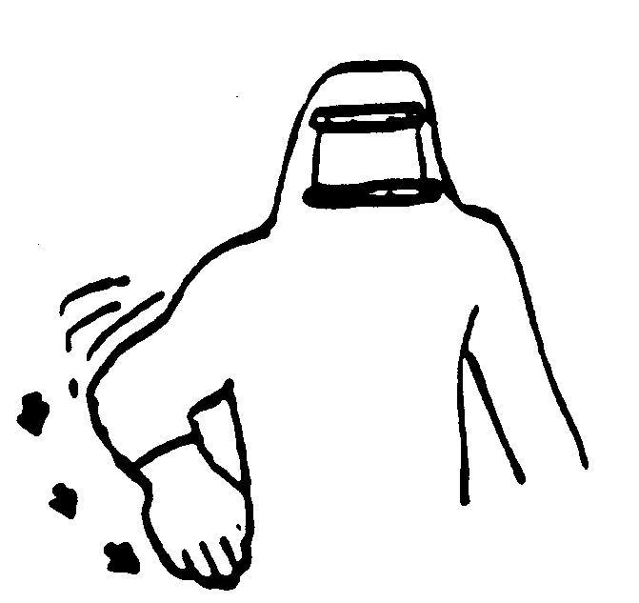
TAKE IT EASY,
SLOW DOWN
ME, OR WATCH ME
YES
NO
YOU LEAD,
I’LL FOLLOW
HANDS RAISED OVER HEAD N CIRCULAR MOTION
I NEED HELP,
I’M IN TROUBLE.
MAYDAY
UNDER, OVER, AROUND

